IJMRI Word Template

1st Author¹, 2nd Author², 3rd Author³

¹1st author's affiliation
²2nd author's affiliation
³3rd author's affiliation
ABSTRACT
The International Journal of Multidisciplinary Research and Innovation (IJMRI) is a peer reviewed; open access multidisciplinary scholarly journal owned and managed by University of Kabianga in Kenya with an aim of providing a single platform that considers all possible academic fields under its broad umbrella. IJMRI publishes original quality research papers, review papers, mini-reviews, case reports, case studies, short communications, letters, and editorials from all disciplines.
Keywords:
Copyright © 2022 The Author(s): This is an open-access article distributed under the terms of the Creative Commons Attribution 4.0 International License (CC BY-NC 4.0) which permits unrestricted use, distribution, and reproduction in any medium for non-commercial use provided the original author and source are credited.

INTRODUCTION
We request that authors adhere to a few simple guidelines. Create a paper that looks exactly like this one simply download the template and replace the content with your own.

SIZE OF THE PAGE
All content on each page should fit inside a rectangle that measures 18 x 23.5 cm (7" x 9.25"), is centered on the page, and starts 2.54 cm (1") from the top and ends 2.54 cm (1") from the bottom. The left and right margins must be 1.9 cm (.75") apart. The text should be in two 8.45 cm (3.33") columns with a .83 cm (.33") gutter.

TEXT TYPESETING

Normal or Body Text
Please use a 9-point Times Roman font, The International Journal of Multidisciplinary Research and Innovation (IJMRI) is a peer reviewed; open access multidisciplinary scholarly journal owned and managed by University of Kabianga in Kenya with an aim of providing a single platform that considers all possible academic fields under its broad umbrella. IJMRI publishes original quality research papers, review papers, mini-reviews, case reports, case studies, short communications, letters, and editorials from all disciplines.

This paragraph is a repeat of 3.1
Please use a 9-point Times Roman font, The International Journal of Multidisciplinary Research and Innovation (IJMRI) is a peer reviewed; open access multidisciplinary scholarly journal owned and managed by University of Kabianga in Kenya with an aim of providing a single platform that considers all possible academic fields under its broad umbrella. IJMRI publishes original quality research papers, review papers, mini-reviews, case reports, case studies, short communications, letters, and editorials from all disciplines.

This paragraph is a repeat of 3.1
Please use a 9-point Times Roman font, The International Journal of Multidisciplinary Research and Innovation (IJMRI) is a peer reviewed; open access multidisciplinary scholarly journal owned and managed by University of Kabianga in Kenya with an aim of providing a single platform that considers all possible academic fields under its broad umbrella. IJMRI publishes original quality research papers, review papers, mini-reviews, case reports, case studies, short communications, letters, and editorials from all disciplines.

Title and Authors
The title (Bookman old font size 18), author names (Perpetua 12-point), and affiliations (Perpetua 10-point) span the entire width of the page, one column wide. E-mail addresses are also recommended (Perpetua 10-point). Three addresses are listed at the top of this page. Center all address text if only one address is required. Use two centered tabs for two addresses, and so on. You may have to improvise for three authors.

Subsequent Pages
Start at the top of the page and use a double-column format for all pages besides the first. The last page's two columns should be as close to equal in length as possible.

Table 1. Captions for tables should be placed above the table
Campuses | Main | Town | Sotik | Kapkatet
Figures | Figures | Figures | Figures | Figures
Figures | Figures | Figures | Figures | Figures

Page Numbering, Headers and Footers
Your submission should not include any headers, footers. The page number should be included.

FIGURES/CAPTIONS
Tables/Figures/Images should be placed as close to the reference as possible in the text (see Figure 1). It may span to both columns. Captions should be of font size 9 and font type Times New Roman. They should be numbered (for example, "Table 1" or "Figure 2"), and the words Table and Figure can be abbreviated to Tab 1 or Fig 1, in case the captions are longer. Table captions should be centered above the table body, while figure captions should be centered beneath the image or picture.

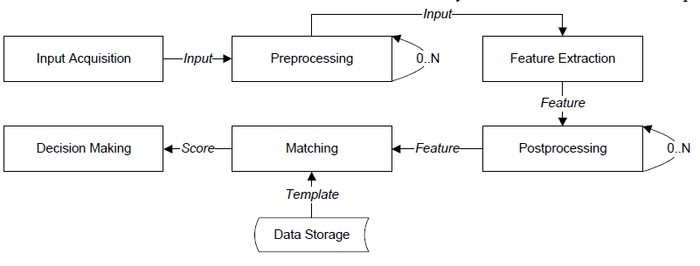
Fig 1: If necessary, the images can be extended both columns

SECTIONS
A section's heading should be in Times New Roman 12-point bold in all-capitals flush left, with an extra 6-points of white space above the section head. Sections and sub-sections should be numbered and flush left.

Subsections
Subsection headings should be in Times New Roman 12-point bold, with only the first letters capitalized

Subsubsections
Subsection headings should be in Times New Roman 11-point italic with initial letters capitalized.

Subsubsections
Subsubsection headings should be in Times New Roman 11-point italic with initial letters capitalized.

Subsubsections
Subsubsection headings should be in Times New Roman 11-point italic with initial letters capitalized.

ACKNOWLEDGMENTS
IJMRI publishes original quality research papers, review papers, mini-reviews, case reports, case studies, short communications, letters, and editorials from all disciplines.

REFERENCES
- Ahmadzadegan, M. H., Khorshidvand, A.-a., & Pezeshki, M. (2015). A method for securing username and password against the Keylogger software using the logistic map chaos function. IEEE .
- Ara, A. (2015). Edging Trust in Cloud Enviroment. International Journal of Scientific Research.
- Barman, S., Samanta, D., & Chattopadhyay, S. (2015). Fingerprint-based crypto-biometric system for network security. EURASIP Journal on Information Security
- Bharti, P., & Soni, R. (2012). A New Approach of Data Hiding in Images using Cryptography and Steganography. International Journal of Computer Applications .
- Catteddu, D. (2010). Cloud computing: benefits, risks and recommendations for information security. Communications in Computer and Information Science.
- Cortese, E. (2012). Scalability and Performance of JADE Message Transport System. Arizona: Semantic Scholar.
- Habib, S., Hauke, S., Ries, S., & Mühlhäuser, M. (2012). Trust as a facilitator in cloud computing: a survey. Journal of Cloud Computing: Advances, Systems and Applications
- Jain, R., & Kant, C. (2015). Attacks on Biometric Systems: An Overview. International Journal of Advances in Scientific Research.
- Tabrizchi, H., & Kuchaki, R. M. (2020). A survey on security challenges in cloud computing: issues, threats, and solutions. J Supercomput.

